Green Flag Application Assessment Criteria

Before applying for the award, it is important to ensure that the “Seven Steps” have been successfully implemented and all steps have been up and running for at least 6 months. The following lists the minimum required for each step:
- A Green-Schools committee has been established and meets on a regular basis.
- An environmental review has been undertaken, which clearly indicates the environmental impact of the school for the theme being undertaken.
- An action plan with realistic and manageable goals has been developed from the review, with some of these goals partially or fully achieved.
- The progress towards achieving these goals has been monitored and displayed.
- The programme has been integrated with the school curriculum when and where possible.
- The whole school has been updated on the progress of the programme and has been involved to some degree. A “day of action” should be part of this process.
- An applicable “Green Code” has been written, adopted, and displayed. The seven steps are the basis of the Green-Schools programme.
When you apply for the award the assessors will be looking for evidence that each of these steps has been adopted. However, it is important to note that the assessment procedure will take account of each school’s individual circumstances.

Application Questions for the Green Flag Award
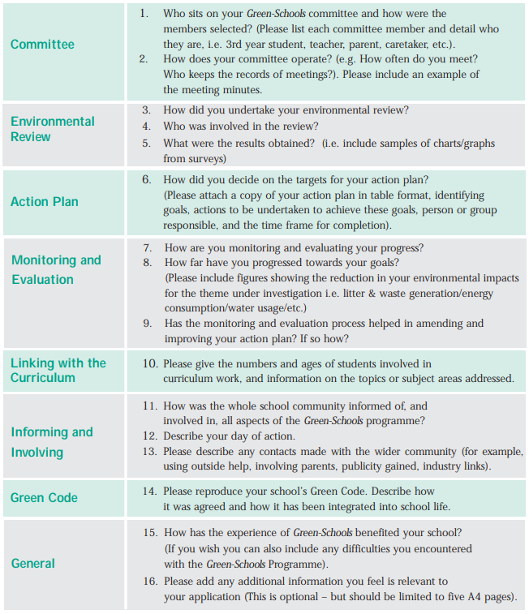
As already outlined, when you feel that you have adequately addressed all the elements of Green-Schools, you can apply for the Green Flag. In order to simplify and standardise the application process, the questions below have been devised to help you clearly outline your Green-Schools programme. You should answer all of the questions and make sure they are clearly numbered. Your answers will give us most of the information needed to decide whether you have achieved Green Flag status.
Photocopy and carefully fill out the Green-Schools Award application form on the following page, and attach it to your application.
Please send three copies of the whole application to:
Green-Schools Office, Environmental Education Unit, An Taisce, Unit 5A, Swift’s Alley, Francis Street, Dublin 8,
Email: greenschools@antaisce.org
Once the Green-Schools Office has received your application, the procedure for assessing your school is as follows:
- An Taisce reviews application and makes recommendations if needed.
- School implements recommendations and sends report to the Green-Schools Office.
- Assessor visits the school.
- Green-Schools evaluation committee makes decision whether to award the Green Flag.
Schools can submit an application for an award at any time of the year. However, there are two sets of award ceremonies during the school year; the first takes place in February/March, and the second takes place in May. If you wish to be awarded at the earlier date, you need to have your application in before the 1st of December, while the deadline for the second set of awards is the 1st of March. If you feel your school is ready to apply early in the school year, the Green-Schools Office would recommend that you aim for the December deadline. This will help to prevent large numbers of applications coming in late in the school year, thus ensuring that all applications can be processed before the end of the school year.
Any applications received after the 1st of March may be carried over until the following school year. It should also be noted that you can make your application in electronic or CD-ROM format

